Summary of what we did in the forced rep study

Every semester I teach a class during which students train once a week doing a HIT-style workout consisting of a full-body workout doing one set each of lat pulldowns, bench press, leg press, leg extension, leg flexion, rowing, crunch, push-up) each to failure, followed by as many reps as possible after a short break of 10-25 seconds after failure.
At the end of each semester we did the following test: The students were asked (after a light warm-up) to put their ~10-12RM for the bench press on a smith machine. Then they were asked to do as many reps (slow, controlled, in good form) as possible. When they reached the point of momentary muscular failure, a spotter assisted just enough to enable the trainee to finish two more repetitions. We measured exactly how much (kg) the spotter contributed to finishing each of the two reps. We used a scale/device that is usually used for weighing suitcases.

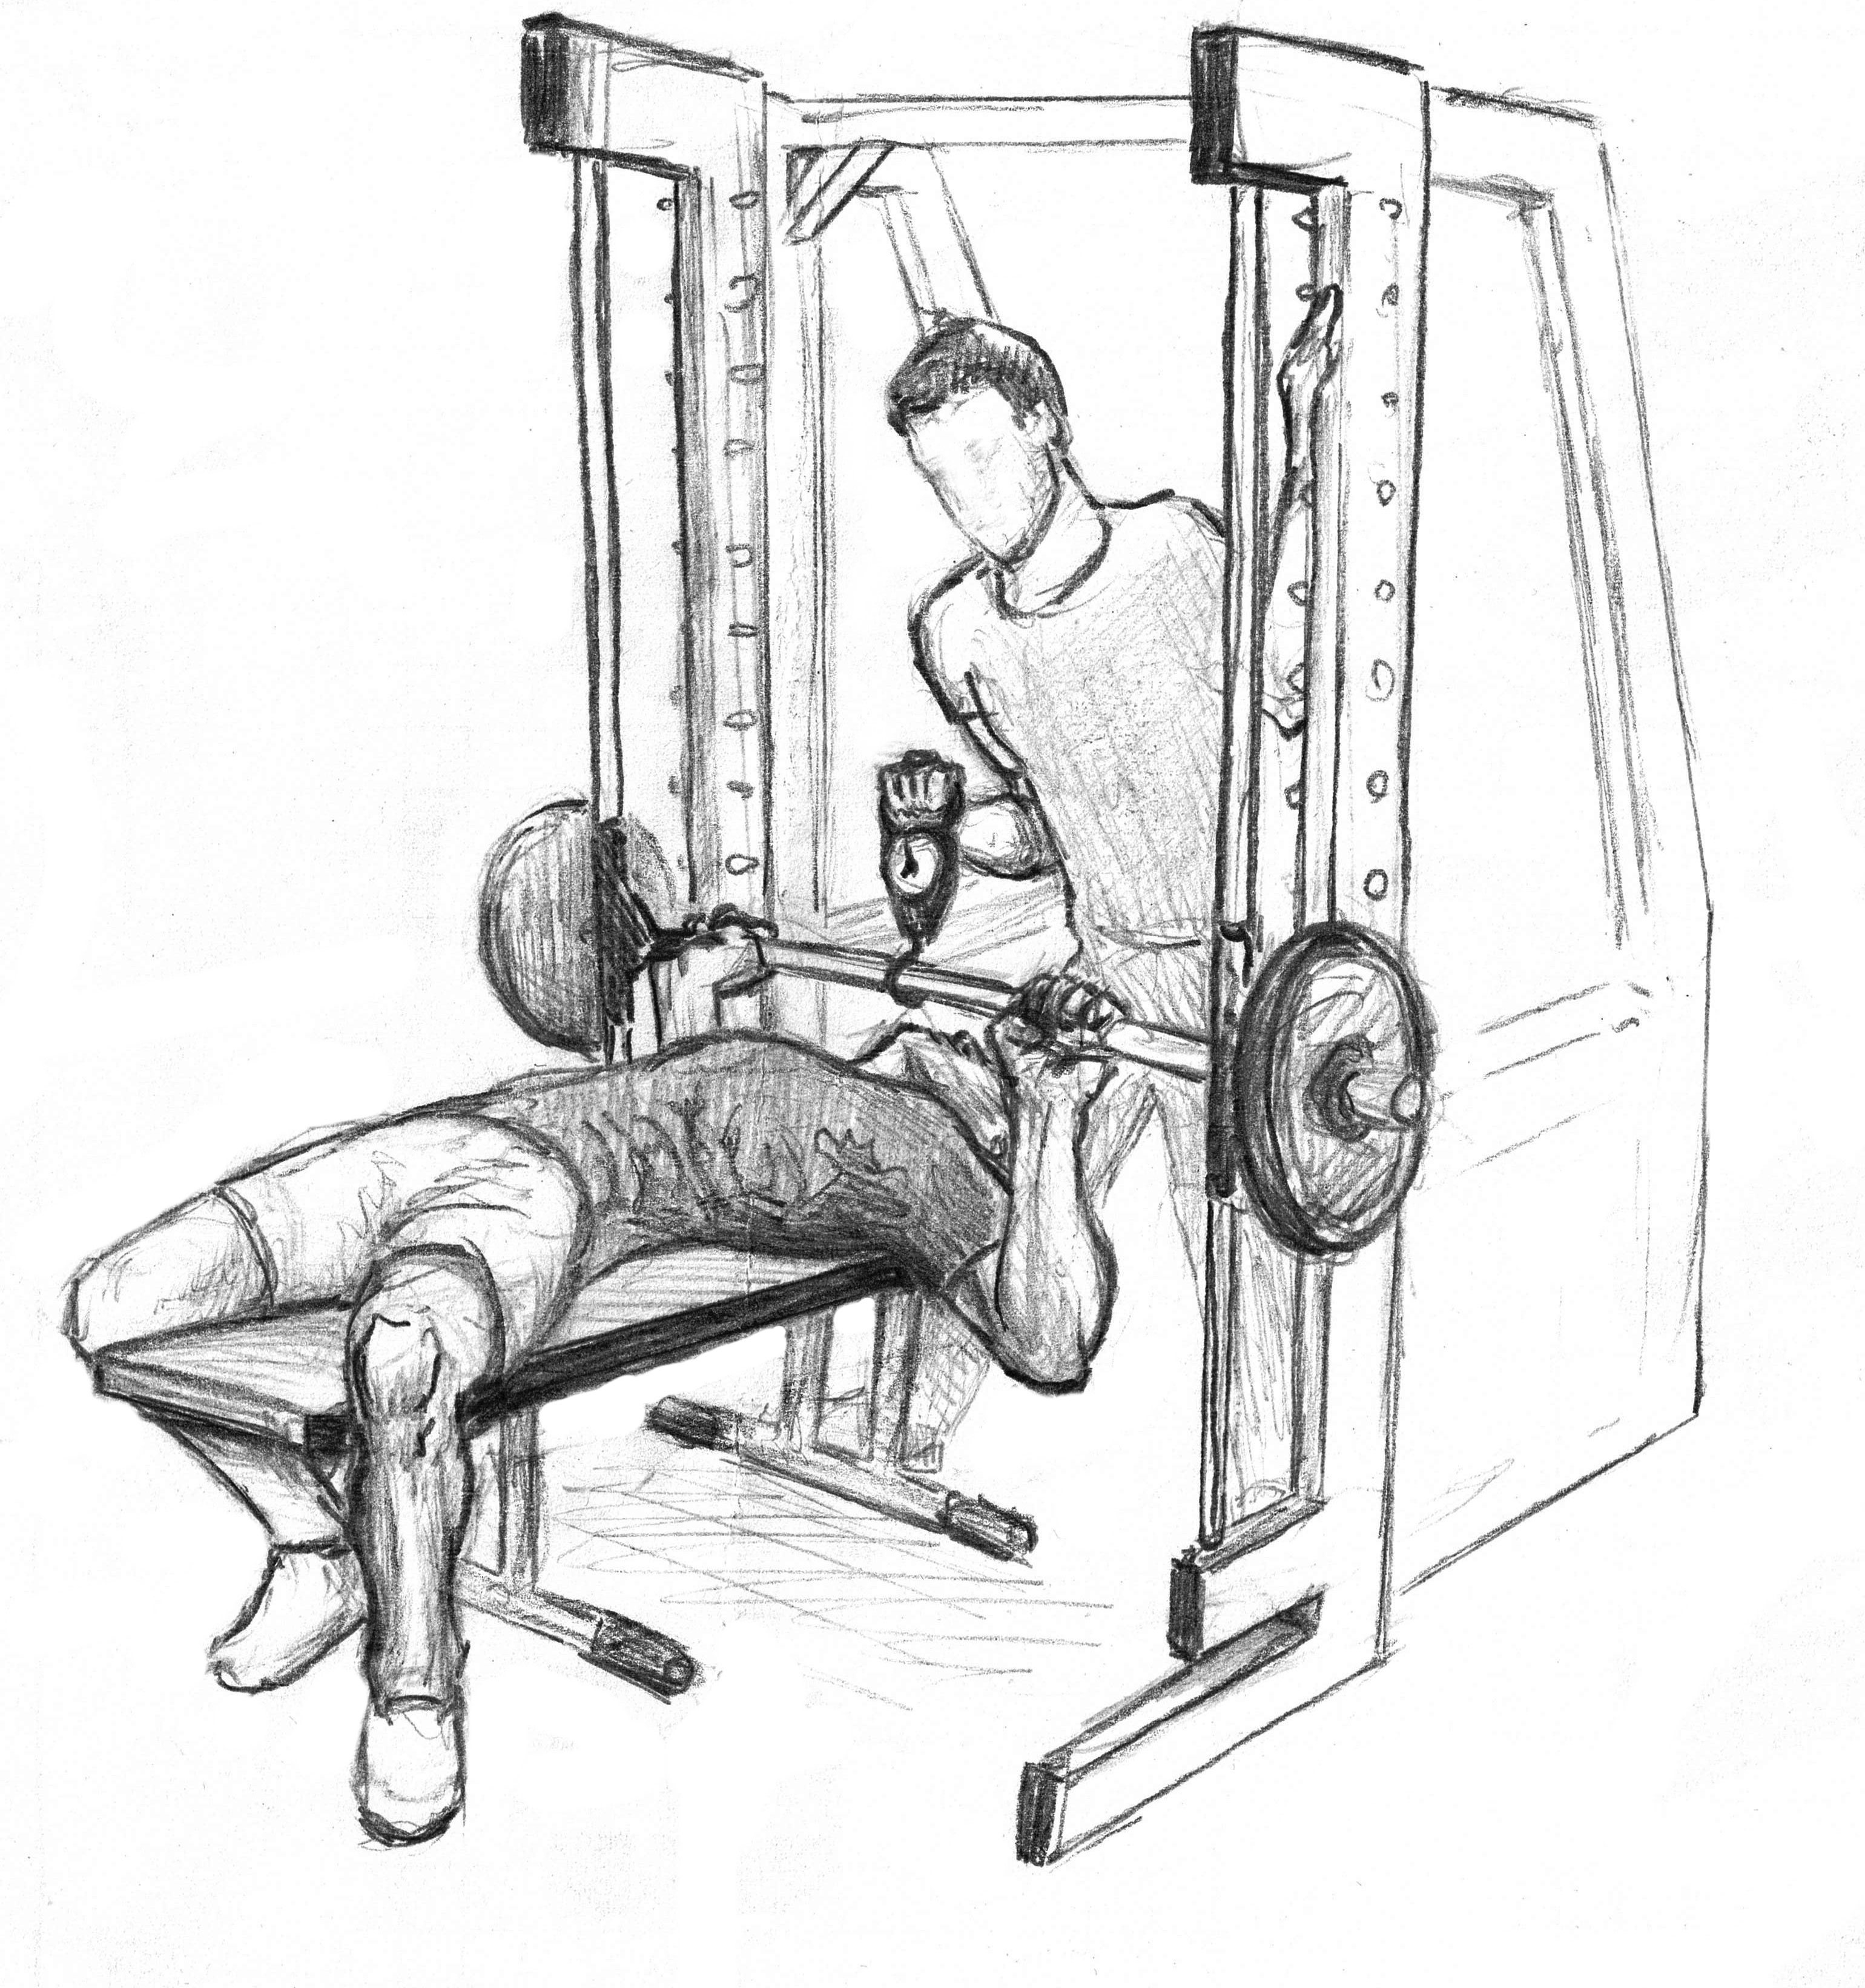

Only we (my assistant and I) could see the result. Neither the trainee nor the spotter could see the numbers measured by the device. My assistant filmed the device all the time so that afterwards we could look up the highest number on the scale. If, for example, the spotter assisted by lifting between 1 kg to 8 kg, we wrote down “8 kg” in the excel data file. After the two forced reps, we separated the trainee and the spotter form each other and asked the trainee “How much (%) did the spotter help you for the first rep and how much for the second? The spotter was asked to guess how much (%) he contributed to finishing rep 1 and rep 2, respectively. We asked them right after the set but took them to different parts of the gym so that they could not hear each other’s answer and did not know what the other one had said.
We were able to look at 36 tests. Unfortunately, for 12 tests, the results of the scale were lost (the files were accidently deleted by my assistant/PhD candidate. I know. I know. I already told him that he is an idiot and he agreed) so that we have 24 complete tests left.

Please see the data in the excel file. This is just a short overview.
Results
Exercise: Bench press (smith machine)
Subjects: n=48 (10f/38m)
Height: MW=178.4 cm/ SD= 7.5
Age: MW=22.8/ SD= 2.8
Body weight: MW=73.3/ SD=9.8
Muscle mass: MW=58.0/ SD=8.5
Muscle mass (%): MW= 79.3/ SD=0.05

:
 | average
repetitions | 13,3
TUT | 94,6
Cadence (sec/rep) | 7,2
EWT1 | 37,4
EWT2 | 50,3
EWS1 | 20,7
EWS2 | 45,9
AW1 | 10,6
AW2 | 18,0

EWT1 weight lifted by spotter as estimated by trainee, forced rep 1
EWT2 weight lifted by spotter as estimated by trainee, forced rep 2
EWS1 weight lifted by spotter as estimated by spotter, forced rep 1
EWS2 weight lifted by spotter as estimated by spotter, forced rep 2
AW1 actual weight lifted by spotter, forced rep 1
AW2 actual weight lifted by spotter forced rep 2

Trainees tended to overestimate how much the spotter assisted (which means they underestimated their own contribution to finishing the rep(s). The spotters also overestimated how much they assisted.

